# Creating a Bot Account

In order to work with the library and the Discord API in general, we must first create a Discord Bot account.

Creating a Bot account is a pretty straightforward process.

1. Make sure you’re logged on to the [Discord website](https://discord.com).
2. Navigate to the [application page](https://discord.com/developers/applications)
3. Click on the “New Application” button.

The new application button.

1. Give the application a name and click “Create”.

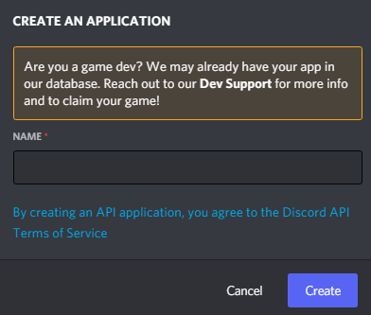

1. Create a Bot User by navigating to the “Bot” tab and clicking “Add Bot”.
   * Click “Yes, do it!” to continue.

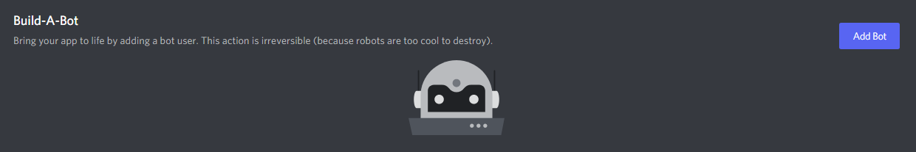

1. Make sure that **Public Bot** is ticked if you want others to invite your bot.
   * You should also make sure that **Require OAuth2 Code Grant** is unchecked unless you are developing a service that needs it. If you’re unsure, then **leave it unchecked**.

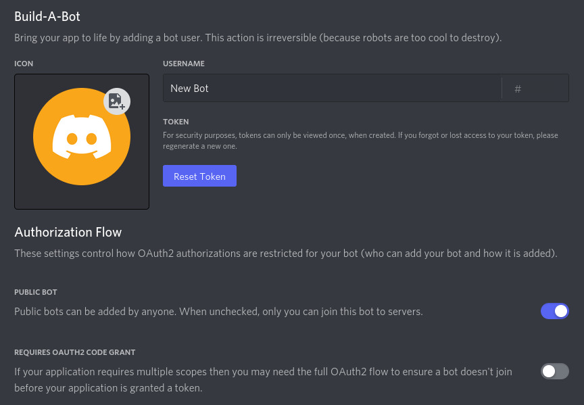

1. Copy the token using the “Copy” button.
   * **This is not the Client Secret at the General Information page.**
2. It should be worth noting that this token is essentially your bot’s password. You should **never** share this with someone else. In doing so, someone can log in to your bot and do malicious things, such as leaving servers, ban all members inside a server, or pinging everyone maliciously.

The possibilities are endless, so **do not share this token.**

If you accidentally leaked your token, click the “Regenerate” button as soon as possible. This revokes your old token and re-generates a new one. Now you need to use the new token to login.

And that’s it. You now have a bot account and you can login with that token.

## Inviting Your Bot

So you’ve made a Bot User but it’s not actually in any server.

If you want to invite your bot you must create an invite URL for it.

1. Make sure you’re logged on to the [Discord website](https://discord.com).
2. Navigate to the [application page](https://discord.com/developers/applications)
3. Click on your bot’s page.
4. Go to the “OAuth2” tab.

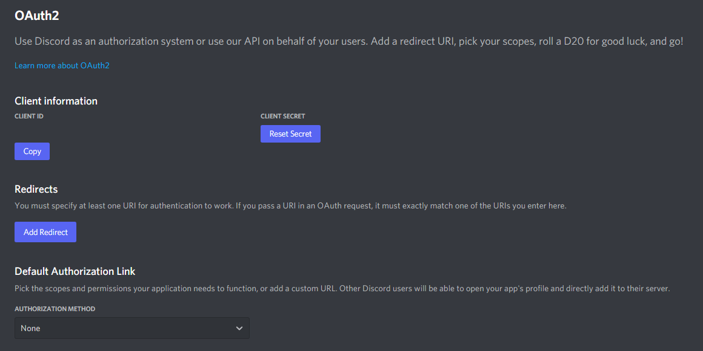

1. Tick the “bot” checkbox under “scopes”.

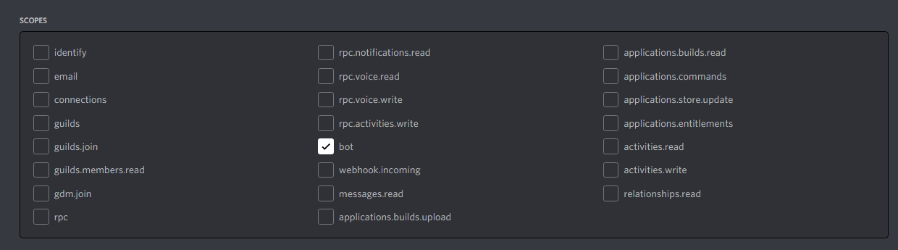

1. Tick the permissions required for your bot to function under “Bot Permissions”.
   * Please be aware of the consequences of requiring your bot to have the “Administrator” permission.
   * Bot owners must have 2FA enabled for certain actions and permissions when added in servers that have Server-Wide 2FA enabled. Check the [2FA support page](https://support.discord.com/hc/en-us/articles/219576828-Setting-up-Two-Factor-Authentication) for more information.

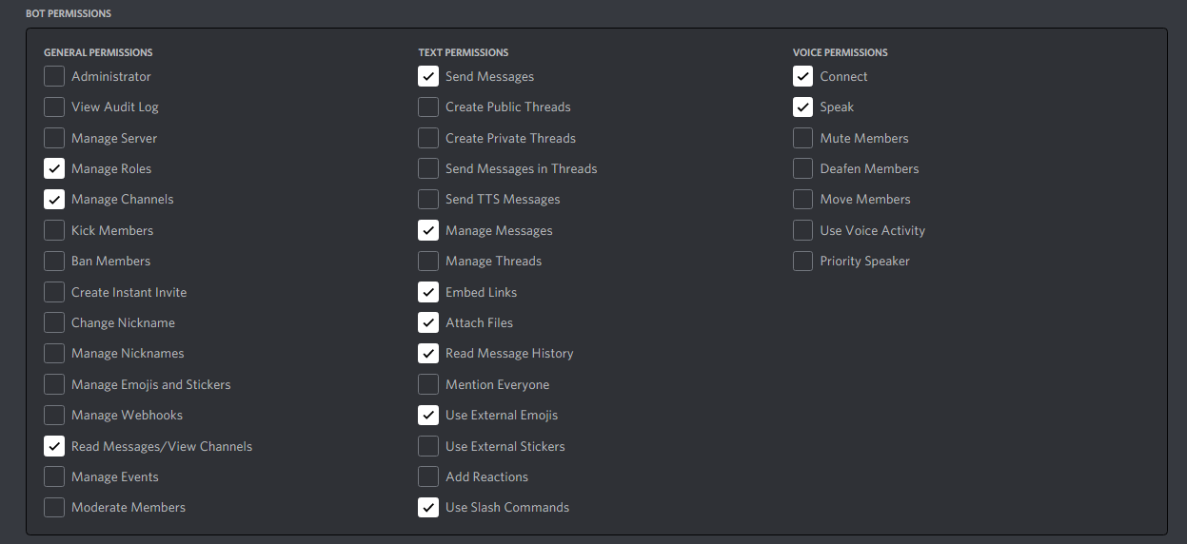

1. Now the resulting URL can be used to add your bot to a server. Copy and paste the URL into your browser, choose a server to invite the bot to, and click “Authorize”.

The person adding the bot needs “Manage Server” permissions to do so.

If you want to generate this URL dynamically at run-time inside your bot and using the [discord.Permissions](https://discordpy.readthedocs.io/en/stable/api.html#discord.Permissions) interface, you can use [discord.utils.oauth_url()](https://discordpy.readthedocs.io/en/stable/api.html#discord.utils.oauth_url).

**Implementing Token Vault for your Discord server –**

Requirements –

1. CloudCoin Coin Manager – v 22.10.16 +
2. Python 3+
3. Git
4. VS Code
5. Clone the BankOnDiscord Repo

Use the following command to clone the repo

Git clone <https://github.com/CloudCoinConsortium/BankOnDiscord.git>

1. Get the token for your bot - Go to the Discord portal Bot screen in step 6 of part 1 to get the token. Click on Reset token to get a new token for your script. This is a one time process and if you loose the token you need to generate a new token.



1. Copy the token
2. Open the cloned repository in VS code or any editor of your choice.
3. Look at Line 20 in the script ccdiscordbot.py and copy the token there.

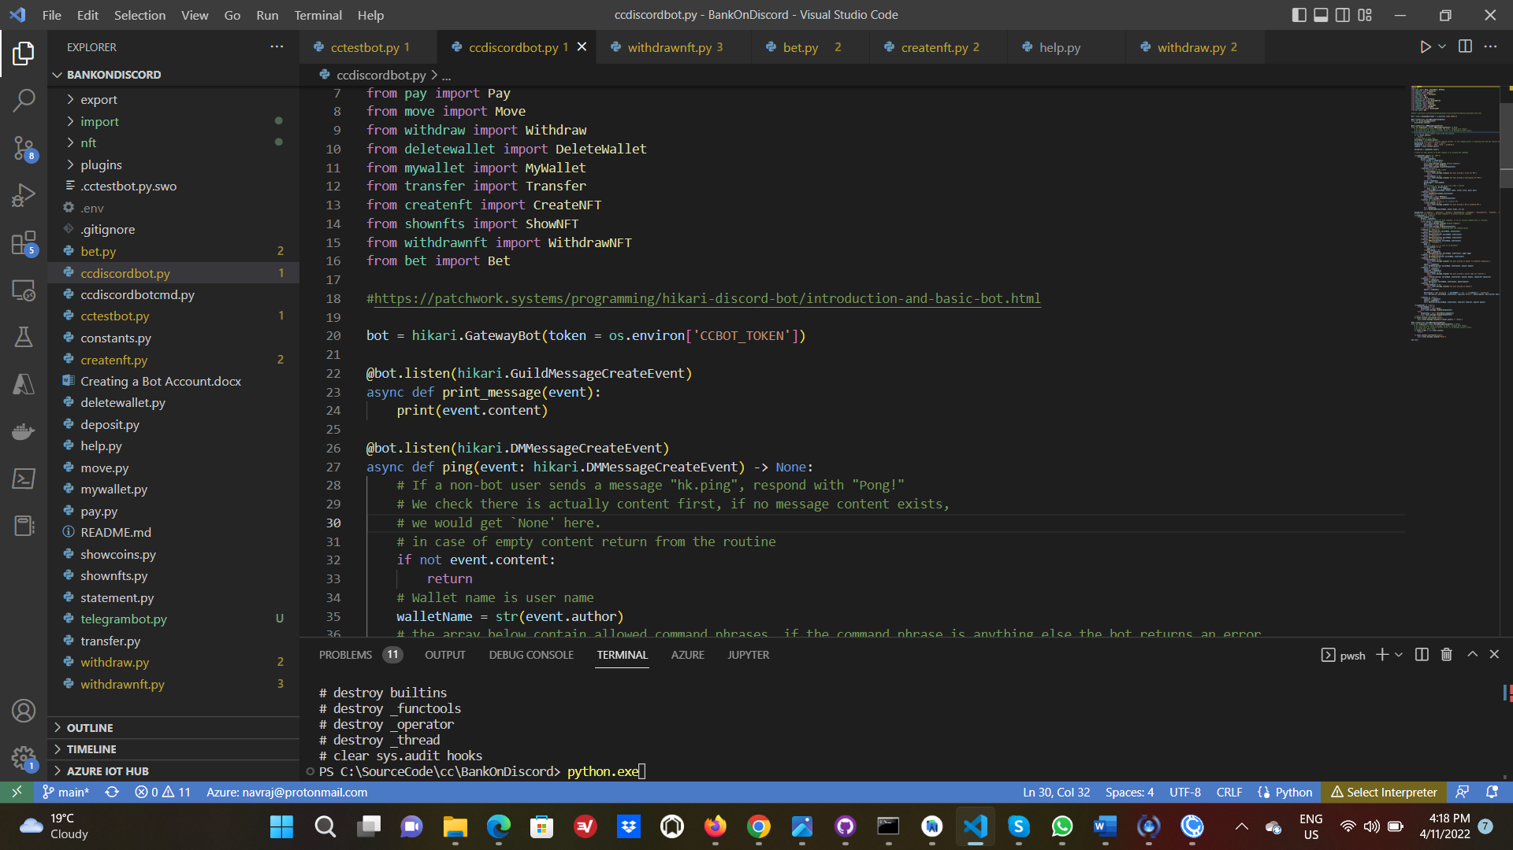

You can either set an environment variable for your OS or choose to copy the token itself there. We recommend using first option of setting the environment variable as it prevents for the token to be exposed because of accidental commit.

1. Update the Base URL for Coin manager API. By default the Coin Manager API runs at url <http://localhost:8888/api/v1/> . There is no need for this step if the Coin manager API runs at the same URL. If however the URL is different, then you can copy paste the Coin manager URL in constants.py as given below.

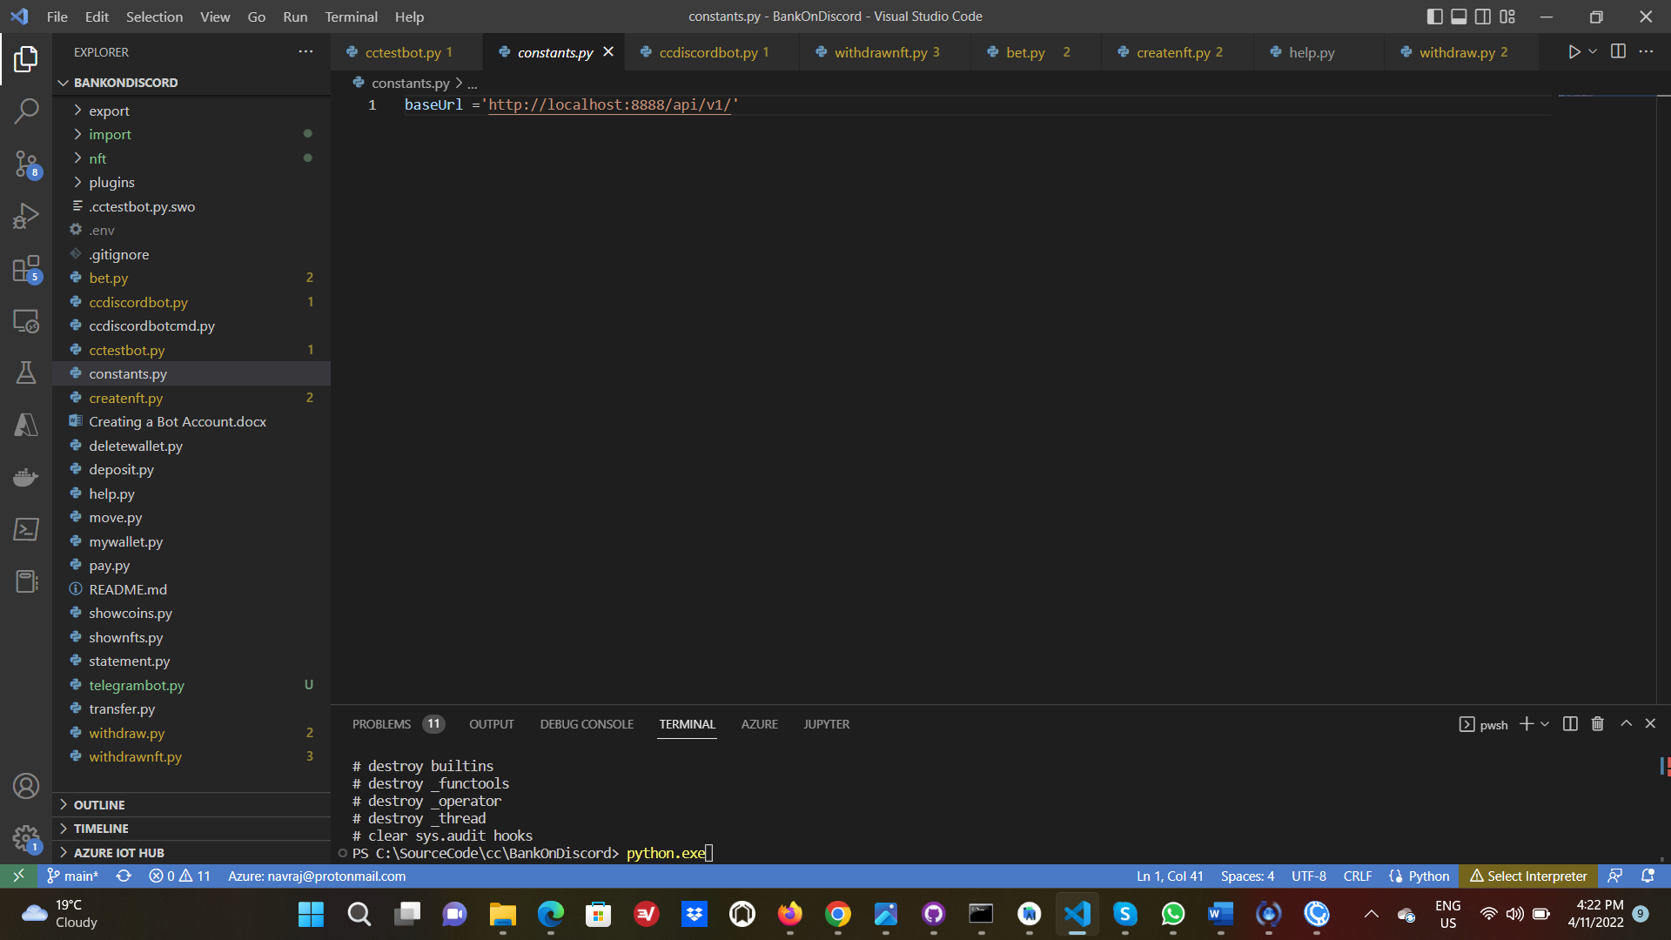

1. Create the folder structure for import and export

For CloudCoin Import please create the following structure in root directory.

/import

/export

/nft

/nft/export

/nft/import

**Please note that if you run the Discord bot as a service using systemctl then the folder location will be root**

/import, /export etc

If however you run directly from source code, the folders can be in the same location as the repository source code

/pathtorepo/import

/pathtorepo/export

For more information on python bots you can refer to following links –

<https://realpython.com/how-to-make-a-discord-bot-python/>

We have used hikari as the library to implement the chatbot. More documentation can be found here –

<https://www.hikari-py.dev/>